Homework

Week 1

Question -

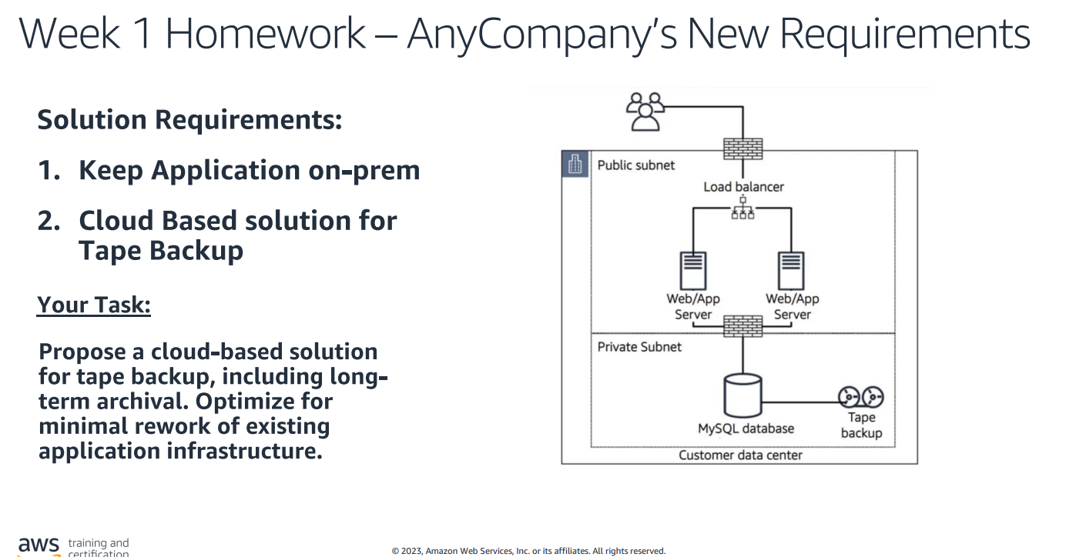

Ans:-

